**GAME IDEAS**

**Packets**

Connect users to data centers with a limited amount of wires or switches.

Users randomly spawn on a grid and have to reach a data center on request.

The packets following the network of wires and must reach there destination in time without being held up by other traffic

Think mini motorways but with networks (mini motorways screenshot below)

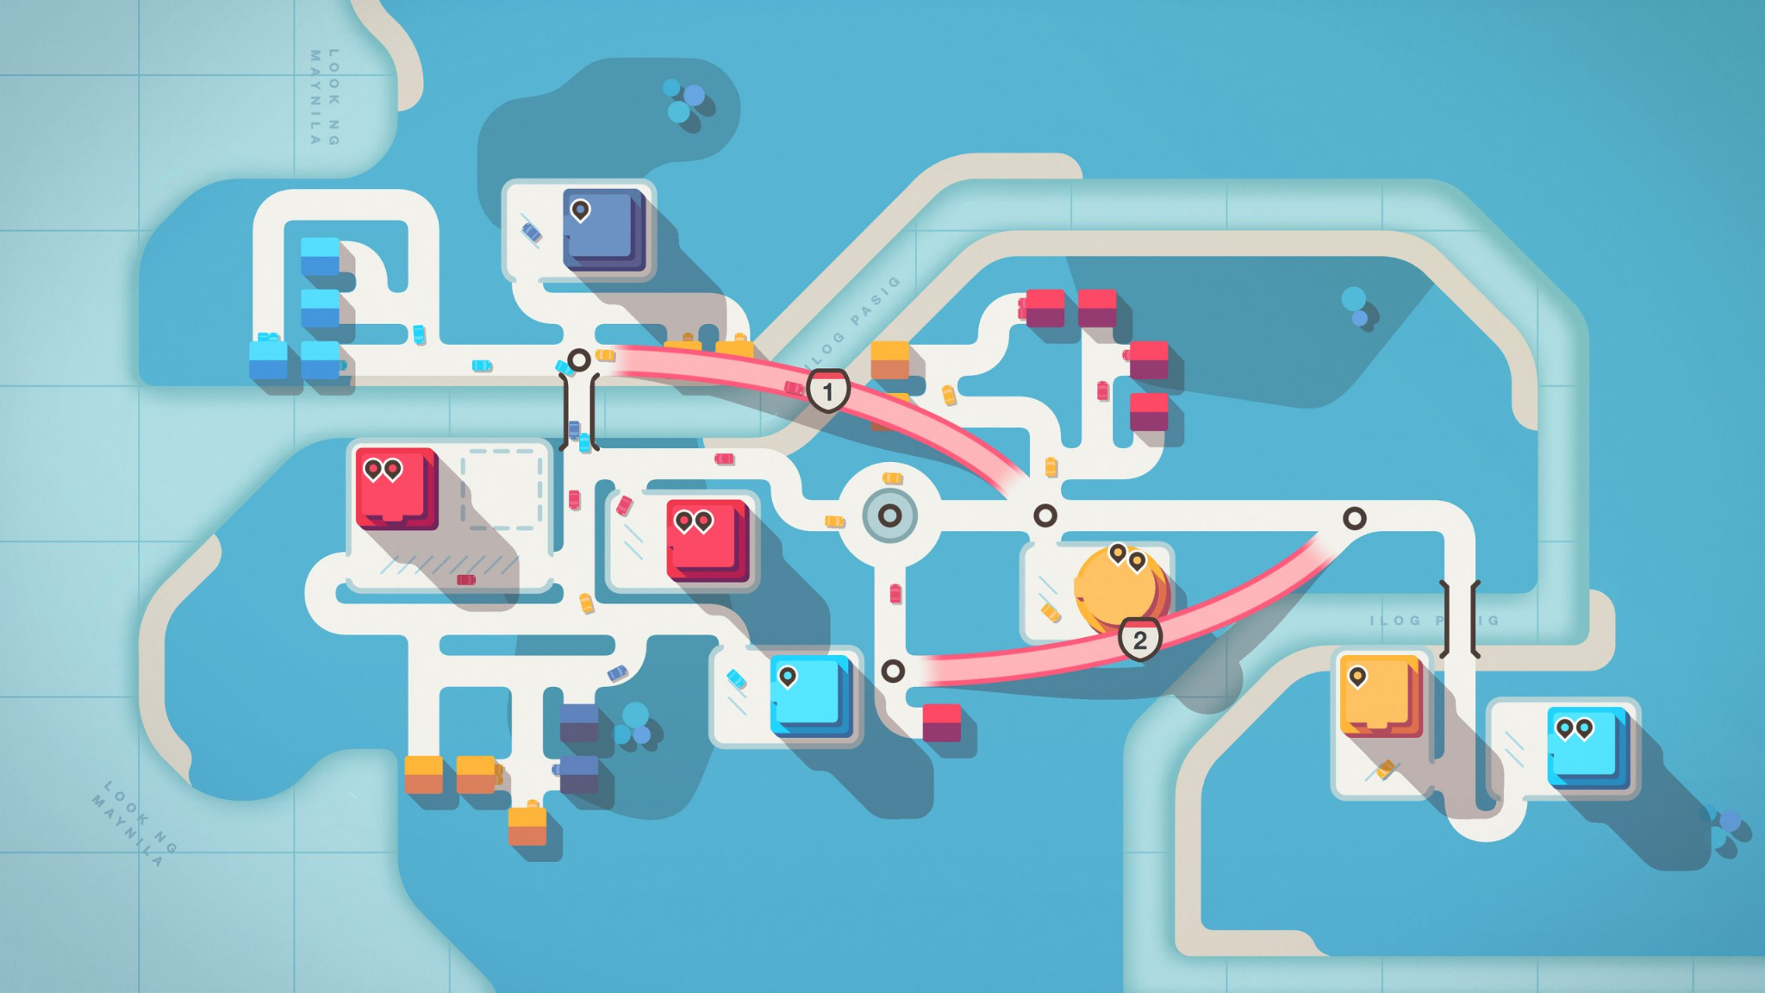

**Its Twins**

You control two toddlers who are trying to escape a house.

You must collect certain pickups along the way

You only control one toddler at once so have to switch between them quickly to overcome challenges such as climbing over baby gates, avoiding adults and the family dog.

If you get caught its back to the start.

Consider It Takes Two combined with Hitman but with toddlers and milk bottles rather than guns

**One More Colour**

- Start off as a black and white game

- Platformer

- Kill enemies through the level - could be spelunky style through caves or side scroller like Mario

- Either at the end of each level the boss's attack shoots a colour and when the boss dies the player picks up the colour or the play picks up colours through other mechanics through the game

- When colours are collect its adds more colour to the level and enhances the ability of the player.

**INSPERATION**

**Untitled Magnet Game**

<https://gmtk.itch.io/untitled-magnet-game> - 2D platformer with novel mechanics - like the small particle effects when the play moves

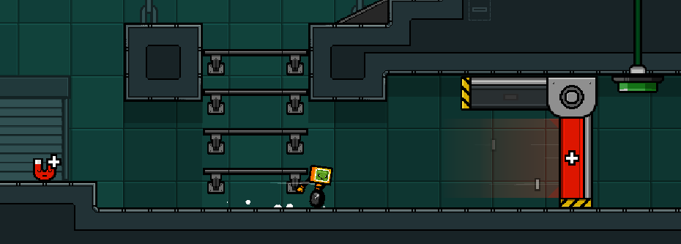

**Help, Np Break**

<https://edgarmendoza.itch.io/help-no-brake> - 2d, fast pace, simple mechanics but feels different to other games I have played

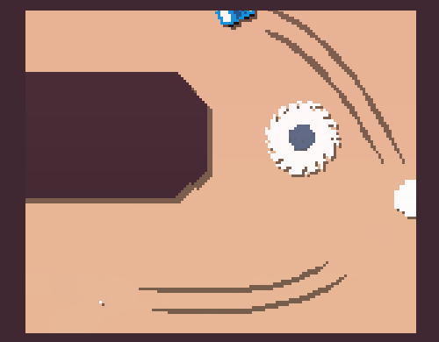

**RE:RUN**

3D - action/parkour - fast paced, puzzle - like the way you pick up skills and reset to the start position with your skill which allows you to progress with the level. Timer indicates you should go faster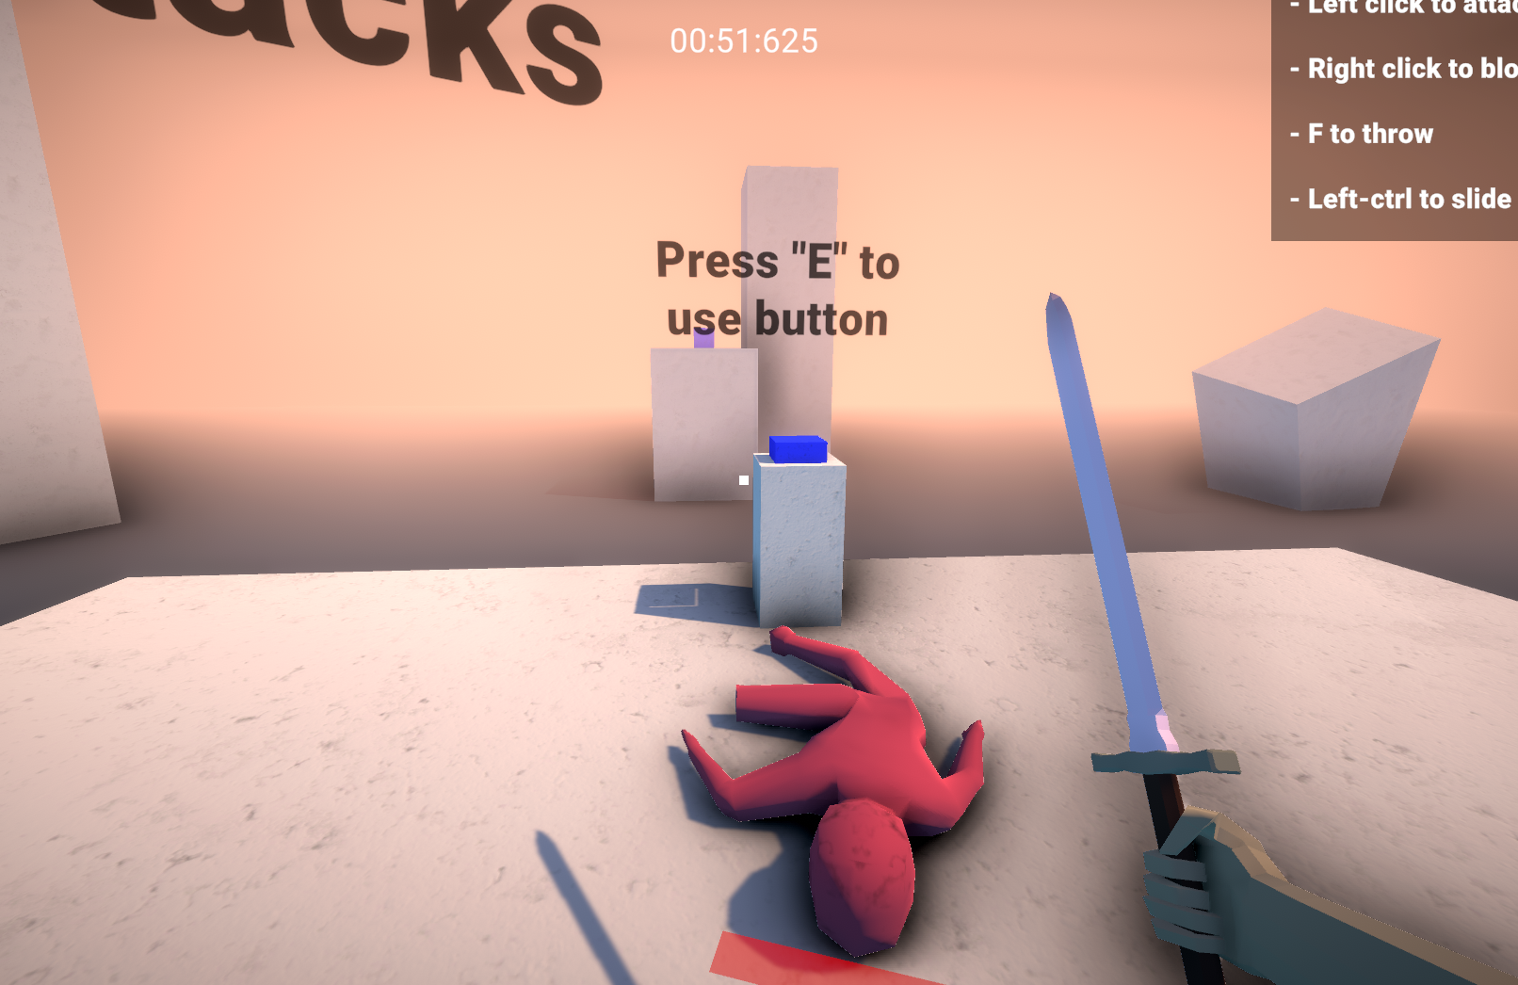

**Geometry Dash**

2D, fast pace. I own this game. All you have to do is jump pressing or holding jump. The levels seem built to the music, the bright colours catch your eye and the way the mechanics are introduced through the levels mean you often fail first but then you start to master and try to remember the level. (Someone made a 3d version of this <https://delugedrop.itch.io/3dash>)

